ACCENTURE INNOVATION CHALLENGE 2026 · TEAM NEXUS
BusinessIntelligence.ai
KPI intelligence-to-action for retail banking
Detailed business proposal · August 2026

The Macro Gap in Banking Analytics
Modern banking analytics infrastructure suffers from a structural disconnect between data ingestion and executive decision-making [1]. Enterprise data teams have deployed scalable cloud data warehouses and visual reporting platforms, yet banking leaders struggle to obtain timely, trustworthy explanations for unexpected metric movements.

- Industry benchmarks show that poor data quality imposes an average annual cost of $12.9 million on enterprise organizations .
- Enterprise data engineering teams encounter an average of 67 data incidents per month, with each incident requiring approximately 15 hours to identify, investigate, and resolve .
- Transaction monitoring systems, such as Anti-Money Laundering (AML) engines, generate baseline alert noise levels with false-positive rates between 90% and 95% .
- Survey evidence reveals that 67% of enterprise organizations lack complete trust in their internal data assets when making critical operational decisions .
- While 91% of retail banking institutions classify artificial intelligence as a top strategic priority, only 23% have successfully scaled AI capabilities beyond localized pilot implementations . Regulatory evaluations show an AI adoption rate of 20.8% among regulated financial entities in major growth markets .

Field | Detail
Prepared for | Finance, operations, risk, analytics and data leadership at a mid-size retail bank
Team | Nexus — Indian Institute of Technology, Patna
Problem statement | BusinessIntelligence.ai (Accenture Innovation Challenge 2026)
Reference build | NexaBank and SafexBank — two tenants running side by side on one engine today
Scope of this document | Problem, solution design, target users, business case, phased roadmap and risk register
Date | 30 August 2026
Status of figures | Cost inputs externally sourced; value lines modelled and labelled line by line

CONTENTS
Section | Section
1 The Macro Gap in Banking Analytics | 6 Phased roadmap
2 Solution design | 7 Key risks and mitigations
3 KPI and domain portfolio | 8 Measurement and success criteria
4 Target users and operating model | 9 Commercial packaging and go-to-market
5 Business case and impact | 10 Recommendation
Appendix A Terms used in this proposal | Appendix B External evidence register

This proposal restates and elaborates the six-page executive deck of the same name. Where the two differ, the deck is authoritative and this document has been corrected to match it.
SUBMISSION

Team details
Team Nexus is a three-person team from the Indian Institute of Technology, Patna, working on the BusinessIntelligence.ai problem statement for the Accenture Innovation Challenge 2026.

Member | College | Stream | Graduation
Omesh Mehta (Team Leader) | Indian Institute of Technology, Patna | Chemical and Biochemical Engineering | 2027
Abhishek Kumawat | Indian Institute of Technology, Patna | Chemical and Biochemical Engineering | 2027
Vinod Singh Rathore | Indian Institute of Technology, Patna | Mechanical Engineering | 2027

EXECUTIVE BRIEF

The decision layer missing from modern analytics
Every bank already has dashboards. The unresolved cost is the day that follows a dashboard alert: proving whether the movement is real, finding where it originated, estimating what happens next, testing whether an intervention explains it, and translating the result for readers who each need a different depth of it. That day is the product’s target.
BusinessIntelligence.ai is a governed intelligence layer that sits between a bank’s operational systems and the people who carry the decision. It monitors declared KPI contracts, checks the quality of the underlying signal before anything is said about it, localises additive movements, forecasts with honest intervals, tests attribution against known interventions, proposes a controlled action from a fixed lever ontology, and phrases the result for a named persona. When the evidence does not support an answer, it does not produce one — abstention is a first-class output, not a failure mode.

Metric | Modeled & Sourced Range | Methodological Basis
Defensible Value Floor | $335,000 – $490,000/yr | Bottom-up sum of analyst capacity reclaim, decision error prevention, reporting reduction, and software license recovery.
Headline Value Potential | $550,000 – $950,000/yr | Includes captured in-time operational decision value and reduced senior analyst turnover.
Capital Payback Crossover | 3 to 5 months post-deployment | Modeled deployment cost profile against phased value realization.
Analyst Investigation Capacity | 5x to 8x throughput multiplier | Measured compression of investigation cycle time from ~6.0 hours to under 60 minutes.
Platform Deployment State | Dual-Tenant Reference System | Operational dual-tenant reference implementation (NexaBank and SafexBank) executing on a shared engine.

INVESTMENT THESIS
The commercial value is not another chart and not another chatbot. It is the compression of time and risk between a metric movement and an owned decision, with an evidence trail that survives a sceptic. The differentiator is negative capability: a system that knows when not to answer, and can trace every figure it does state back to a recorded row.
1 / PROBLEM FRAMING

The cost is not measurement. It is the day after the alert.
Four externally published figures frame the size of the gap. They are not our numbers; they are the numbers a sceptical buyer will already have seen, and they describe the same failure from four directions — cost, volume, precision and trust.

$12.9M  Average annual cost of poor data quality per organisation  Gartner, 2020 | 67 / month  Data incidents per data team; ~15 hours to resolve each  Monte Carlo / Wakefield, 2023 | 90–95%  False-positive rate on AML transaction-monitoring alerts  OCC / Datos Insights, 2023 | 67%  Of organisations do not completely trust their data for decisions  Precisely / Drexel, 2025
Gartner 2020 is a self-estimate by enterprise reference customers; Monte Carlo is a vendor-commissioned Wakefield survey (n=200). These anchor the scale of the problem, not the size of our claim.

1.1 The analyst-day
A single metric investigation at a mid-size retail bank consumes roughly six analyst hours. The distribution of those hours is the whole argument: verification, reconciliation and segmentation — the mechanical parts — take the overwhelming majority, and judgement, the part only a human can supply, receives what is left. Roughly twelve movements per week are investigated across a typical team.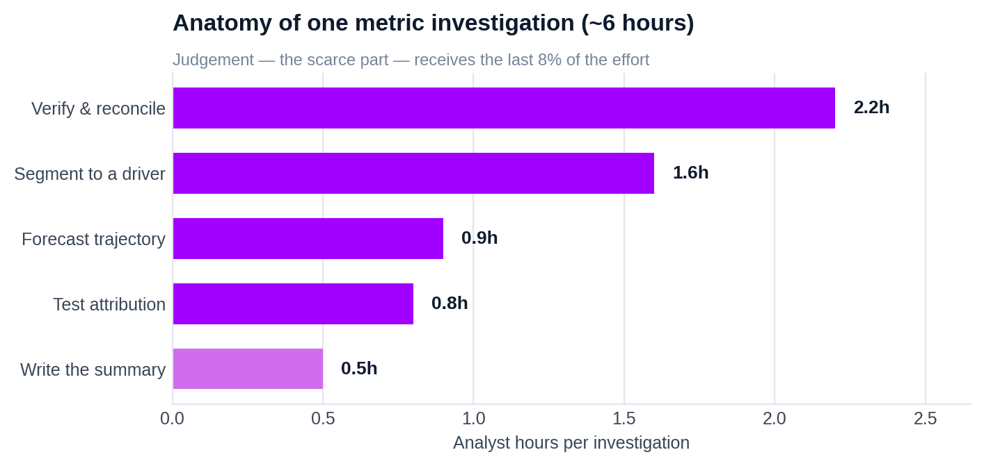
Verify and reconcile (2.2h) and segment to a driver (1.6h) consume 63% of the investigation. Writing the summary — the only artefact the business actually reads — takes 0.5h, or about 8% of the effort.
The ratio is inverted from where the value sits. The last 8% of the effort produces the only output a decision-maker consumes; the first 92% is reconstruction work that a deterministic system can do faster, more consistently and with a permanent audit trail. At $55 per loaded analyst hour and roughly 600 investigations a year, that reconstruction work alone costs about $165K per year in analyst time.

1.2 Three mechanisms that cost money every year
The status quo does not fail loudly. It leaks through three mechanisms, each of which is measurable and each of which the product addresses with a different stage.

# | Mechanism | Annual cost | What actually happens
1 | The analyst-day | $165K/yr  analyst time | Verification, reconciliation and segmentation consume the investigation; judgement — the scarce part — gets what is left. Roughly twelve movements are investigated per week across a typical team.
2 | The confidently wrong answer | $120–160K/yr  avoidable decisions | A duplicated batch produces a statistically real-looking spike. Charts render it, alerts fire, a meeting is held. The movement never happened; the decision taken on it did.
3 | The reporting bottleneck | $33K/yr  duplicated reporting | CFO, operations and risk need one truth expressed three ways, with different figures visible to each. Built by hand, three times, from one spreadsheet — labour cost plus leak risk.

1.3 The recurring cost of the status quo
Scoped to the baseline institution used throughout this proposal — a mid-size retail bank with ten governed metrics — the recurring cost decomposes into five lines. Two are anchored to external sources; three are modelled from stated volume and unit-cost assumptions and are labelled as such.

Cost mechanism | Annual volume | Unit cost | Annual cost | Evidence basis
Analyst investigation time | 600 investigations | 6 h @ $55/h | $198,000 | Cost input sourced
Decisions taken on false movements | 5–8 incidents | $25–60K each | $120–160,000 | Modelled
Duplicated persona reporting | 375 person-hours | $55/h | $20,600 | Modelled
Audit trail reconstruction | 2 cycles | 80 h/cycle | $8,800 | Modelled
Idle entitlements on analytics tooling | 52.7% of licences | — | $50–100,000 | Zylo, 2025
Costs marked ‘modelled’ derive from the stated volume and unit-cost assumptions above, not from client measurement. The idle-entitlement line is anchored to Zylo’s 2025 finding that 52.7% of purchased SaaS licences go unused.

1.4 Why the existing stack cannot close it
Every institution in the target segment already owns at least three of the four categories below. None of them closes the gap, and the reason in each case is structural rather than a matter of feature maturity.

BI dashboards — Power BI, Tableau, Qlik  Show what changed. They hold no opinion on whether the change is trustworthy, so the burden of proof lands on the analyst every single time. A dashboard cannot refuse to render a corrupted series. | Alerting tools  Report that something changed, at a volume that gets them muted. AML transaction monitoring runs at a 90–95% false-positive rate; the organisational response to an untuned alerting surface is always the same — stop reading it.
Conversational add-ons  Produce a fluent answer even when the data does not support one. The best models score roughly 21% on enterprise-schema text-to-SQL against roughly 91% on academic benchmarks, and a wrong answer arrives in the same confident prose as a right one. | Data observability  Catches the broken pipeline, then stops. No segment, no cause, no action, no persona. It tells engineering that a table is stale; it never tells the operations manager which branch cohort to call.
The four categories are complements, not competitors. BusinessIntelligence.ai consumes their outputs — freshness signals, pipeline health, the warehouse itself — and adds the layer none of them occupies: a verdict on whether a movement may be spoken about, and to whom.

1.5 Market Opportunity Sizing (TAM / SAM / SOM)
The exact bottom-up financial sizing calculations—establishing a Total Addressable Market (TAM) of $641.7M, a Serviceable Addressable Market (SAM) of $147.6M, and a 3-Year Serviceable Obtainable Market (SOM) growing from $450,000 to $4,500,000 Annual Recurring Revenue (ARR)—are not included in the core proposal document.
The underlying data points used to construct these market funnel calculations are present in the core document's reference registers. Appendix B of the main proposal cites official regulatory statistics from the Federal Deposit Insurance Corporation (FDIC) Q1 2026 Profile establishing a baseline of 4,278 insured US retail banking institutions. Similarly, the main document cites benchmark research from Accenture (2026) and the Reserve Bank of India FREE-AI Committee (2025) establishing that while 91% of banks prioritize AI strategically, only 23% possess the data maturity and operational complexity required to scale AI capabilities beyond localized pilots. The pitch additions synthesize these regulatory statistics and industry benchmarks into a bottom-up market opportunity model grounded in a standardized $150,000 Average Contract Value (ACV).

Market Funnel Tier | Institutional Scope | Derivation & Filtering Logic | Annual Value ($)
Total Addressable Market (TAM) | 4,278 FDIC Retail Banks | Total US insured retail institutions x $150,000 baseline | $641,700,000
Serviceable Addressable Market (SAM) | 984 ICP Institutions | 23% AI readiness filter applied to TAM footprint | $147,600,000
Serviceable Obtainable Market (SOM - Year 1) | 3 Captured Accounts | Initial commercial pilot conversions $150,000 | $450,000
Serviceable Obtainable Market (SOM - Year 2) | 12 Captured Accounts | Regional bank expansion $150,000 | $1,800,000
Serviceable Obtainable Market (SOM - Year 3) | 30 Captured Accounts | 3-year phased capture scenario $150,000 | $4,500,000
2 / SOLUTION DESIGN

Eight stages, one gate, and a narrator that only phrases
The architecture is an eight-stage chain. Specialist stages compute every number deterministically and on CPU only; a single stage may call a language model, and that stage does no arithmetic. Stages 01–07 complete before the narrator is invoked, and it receives typed evidence bundles — never raw events. The Trust Gate sits at position 02 precisely so that it can stop the chain and emit nothing.

# | Stage | Method | What it decides
01 | Foundation | Ingest API → Kafka → ClickHouse; a KPI contract declares each metric | What the number means, at what grain, from which fundamentals, and who may see it
02 | Trust Gate | Invariants, cross-source reconciliation, value range, freshness against SLA | Whether this figure may be used at all — and if not, what is emitted instead
03 | Detect | Robust residuals and change-point detection; material moves only | Whether something moved enough to be worth a human’s attention
04 | Localize | LMDI-I decomposition and PSqueeze multi-dimensional slicing | Which dimension cells carry the movement, and how much each contributes
05 | Forecast | Chronos-2 zero-shot; band anchored to the Detect baseline | What to expect next, with an interval rather than a point estimate
06 | Causal | BSTS on known interventions; counterfactual with an interval | How much of the movement is attributable to a known intervention
07 | Decide | Contextual bandit over a fixed lever ontology; never invents | Which approved lever to propose, to which named owner, at what expected impact
08 | Narrate | Persona-shaped text from evidence bundles; every number re-checked | How the finding reads for this specific reader, at this entitlement tier
Observe runs across all eight stages rather than after them: it logs latency, token consumption, cost and verifier status per stage, which is what makes the run cost of the system a measured quantity instead of an assumption.

2.1 Reference architecture
The platform is deliberately composed of bounded services rather than one analytics application. The data platform terminates in ClickHouse; the intelligence layer reads through a Metric API and writes findings to the Signal Store; delivery is a dashboard plus a human approval step that no action bypasses.
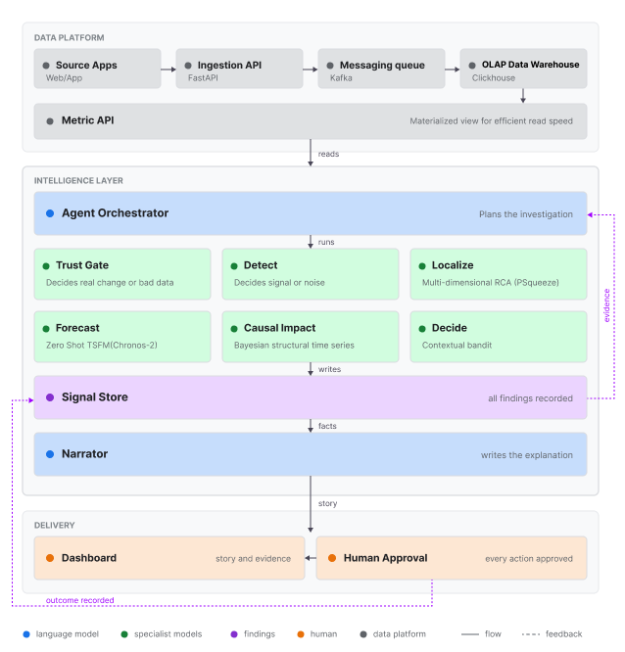
Data platform, intelligence layer and delivery. The dotted return path is the feedback loop: every outcome is recorded against the finding that proposed it.
Two properties of this diagram carry most of the governance weight. First, the intelligence stages never query raw events — they ask the Metric API for declared, additive fundamentals at an explicit grain, which keeps a free-form answer engine from becoming an ungoverned SQL layer. Second, the Signal Store sits between the specialists and the narrator, so the narrator physically cannot see anything that has not already been computed, verified and recorded.

2.2 The Trust Gate — five input conditions, five different emissions
This is the component the rest of the proposal rests on. Most analytics systems have exactly two states: answer, or error. The Trust Gate has five, and each produces a different artefact for the business and a different artefact for engineering. Refusal is not a degraded response; it is a designed output with its own downstream handling.

Input condition | Verdict | What is emitted to the business | Emitted to engineering
Hard invariant fails | QUARANTINE | Nothing. The metric is withheld and the movement is never narrated. | Incident note with the failing check
Movement is real and material | PASS | Full finding: trust, driver, trajectory, cause, action, owner. | —
History too short to trust | WIDE BAND | Movement and localisation only; forecast returned as an explicit wide band. | Coverage note
Defect and real event both plausible | ABSTAIN | Ranked hypotheses, what is missing, and the cheapest check to settle it. | Data request
Reader not entitled | WITHHOLD | Figure structurally absent from the bundle; back-computable proxies removed too. | Access-decision log

WHY FIVE STATES AND NOT TWO
A binary gate forces every ambiguous case into one of two wrong answers: publish a number that might be an artefact, or suppress a movement that might be real. The middle three verdicts exist because those are the cases that actually occur. WIDE BAND keeps a genuine movement visible while refusing to pretend the forecast is tight. ABSTAIN converts a stalemate into a work item by naming the cheapest check that would settle it. WITHHOLD removes a figure structurally rather than redacting it afterwards, which is the difference between an entitlement control and a display rule.

2.3 Design properties the business claims rest on
Four properties are load-bearing. Each one is the reason a specific commercial claim elsewhere in this document is defensible, and each is testable at a phase gate rather than asserted.

Determinism  Specialists compute every number deterministically and CPU-only. Only one stage may call a model, and no stage requires training data. The same frozen rows produce byte-identical numeric outputs, which is what makes a figure reproducible in an audit six months later. | Optional narrative  Turning the narrator off changes no number. Findings fall back to a bounded template, and the numeric verifier re-checks every figure before it ships. The bank is therefore never operationally dependent on an external language service.
KPI contracts  One YAML per metric: formula, grain, materiality threshold, refresh SLA, entitlement scope, permitted dimensions, owners and levers. Onboarding a new institution is configuration, not a rebuild — which is what converts a bespoke build into a repeatable sales motion. | In-tenant residency  Signal Store on ClickHouse; the narrator runs in-tenant. Raw events never enter the model context — which is also the prompt-injection surface. Nothing that has not passed through the Metric API can reach the language layer at all.

2.4 The contract is the portability layer
The platform does not hard-code banking meaning into the reasoning engine. A KPI contract declares its name, formula, source fundamentals, time and entity grain, allowed dimensions, readiness and quality checks, causal ceiling, action levers and visibility list. Tier 0 discovery provides conservative statistical coverage for any measurable activity that has data; Tier 1 contracts add the business semantics a machine cannot safely infer — ratios, invariants, access restrictions, interventions, levers and graph edges.
The commercial consequence is direct: onboarding a new fintech product means mapping its event vocabulary and writing its KPI contracts. It does not mean rewriting the reasoning stages. That is the difference between a consulting engagement and a product.

2.5 Data sources and the event path
- Clickstream: real-time event activity, used for behaviour and corroboration. Synthetic dimensions are explicitly marked in the contract rather than presented as measured fact, and are refused from localisation outside seeded datasets.
- Core banking: applications, accounts, cards and transactions, loaded on a watermarked batch path. This is the authoritative outcome source for lending metrics; clickstream corroborates but never replaces it.
- CRM and marketing: customers, campaigns and interactions, used for acquisition efficiency and product launch context.
- Branch operations and macro environment: measured geography and external context, which is what allows a regional explanation to be stated as a driver rather than a coincidence.

A customer or simulator action creates a source event with an event identifier and session context. The forwarder sends it asynchronously to the ingestion API, where the envelope is validated, metadata sanitised, taxonomy resolved and tenant enforced. Events travel through Kafka when available, with a direct ClickHouse fallback when the broker is down; the processor writes durable rows and parks poison messages in a dead-letter table. Separately, watermarked extracts bring core banking, CRM and market operations facts into ClickHouse. Because delivery is at-least-once, every count uses exact-distinct aggregation and Bronze stays append-only with both event and ingest timestamps preserved — duplicates are reconciled at the Trust Gate rather than silently inflating a KPI.
3 / KPI AND DOMAIN PORTFOLIO

A portfolio designed around decisions, not around tables
The reference build governs ten Tier 1 business metrics across seven domains. Each contract declares what the number means, the additive fundamentals behind it, the grain at which it is valid, its quality checks, permitted dimensions, ownership, allowed actions and visibility. Three of the ten are live end-to-end on NexaBank telemetry today and form the Phase 1 evidence set; the remainder are authored and are the Phase 1 exit target.

Domain | KPI | Decision it enables | Primary audiences
Revenue | Transaction Fee Revenue | What are we earning from customer activity? | CFO, Analyst
Revenue | Pro Revenue (modelled) | What are premium feature conversions worth? | CFO, Analyst
Deposits | Net Deposit Growth | Is money flowing in or out, and from where? | CFO, Operations, Analyst
Acquisition | Cost Per Acquisition | What are we paying to win a customer? | CFO, Analyst, Marketing
Lending | Loan Approval Rate | What share of submitted applications reach approval? | CFO, Operations, Risk, Analyst
Lending | Loan Approval Volume | How much lending is actually being booked? | CFO, Operations, Risk, Analyst
Onboarding | KYC Completion Rate | Where are applicants abandoning onboarding? | CFO, Operations, Risk, Analyst
Growth | New Account Openings | Is the customer base growing? | CFO, Operations, Marketing, Risk
Digital | Digital Adoption Rate | Are customers moving off branch and ATM channels? | CFO, Operations, Marketing
Product launch | Student Travel Card Activations | Is the new product launch landing? | CFO, Operations, Marketing
Pro Revenue is a modelled figure and carries a qualifier every time it is presented, in every persona. A modelled value that loses its label on the way to a slide is exactly the failure the Trust Gate exists to prevent.

3.1 Lending and onboarding: the connected story
The lending domain shows why a governed layer beats a set of independent dashboards. KYC completion is an upstream onboarding signal; loan applications and approvals are downstream lending outcomes. Because the contracts declare the edge between them, a related movement across the two becomes one driver chain rather than three separate alerts arriving in three separate channels.
Source discipline matters here. Loan approval rate is measured from core banking applications at application grain. Clickstream events corroborate activity but never replace the authoritative outcome source, and the contract says so, which means an analyst challenging the figure can see which source produced it without asking anyone.

EXAMPLE BUSINESS ANSWER
“Loan approval volume declined after KYC completion weakened in the same operating window. The lending outcome is sourced from application status in core banking; the clickstream is corroboration only. The next proposed action is to review the KYC step and approval rules, pending lending-operations approval.”

Note what that answer contains and what it does not. It names the source, states the direction of the chain, proposes exactly one lever from the approved list, and defers to a named human function. It does not assert causation it cannot support, and it does not invent an action outside the contract’s lever ontology.

3.2 Coverage that scales without rewriting the engine
Tier 0 discovery gives conservative coverage for every measurable activity with data — conservative in both the statistical sense and the entitlement sense, since an undeclared metric defaults to the most restrictive visibility. Tier 1 contracts then add the semantics that cannot be inferred. The onboarding motion is therefore: describe the institution’s KPIs, point the Metric Layer at its fundamentals, and leave the reasoning stages untouched.
4 / TARGET USERS AND OPERATING MODEL

One engine, three personas today, more by configuration
The buying centre and the usage centre are different people, and a proposal has to serve both. Three personas — CFO, Operations Manager and Analyst — are resolved server-side and live today. The remaining three in the matrix below are Phase 2, and adding them is a configuration change rather than an engineering one.

Role | Today | With BusinessIntelligence.ai | Cadence | Tier
CFO | Waits for a weekly pack; follow-ups take days | Position and outlook on demand; modelled figures always labelled | Weekly + ad hoc | Full
Operations Manager | Knows a metric fell; guesses the segment | Named segment, named lever, named owner, impact as a range | Daily | Full
Analyst | Spends the day verifying and segmenting | Reviews and challenges a completed investigation | Daily | Method
Risk / Audit | Reconstructs how a figure was produced, after the fact | Reads the evidence bundle: metric_id, query hash, source freshness, confidence | Per cycle | Full
Product / Commercial | Guesses which paid features earn their licence | Sees idle entitlements and unlicensed usage directly | Monthly | Restricted
Engineering | Learns data was wrong when someone disputes a number | Trust Gate quarantine raises an incident note before the business sees the number | Event-driven | Technical
A persona changes emphasis, depth and entitlement — it never changes the underlying number. Operations and Analyst are both entitled to KYC Completion Rate, Loan Approval Rate and Loan Approval Volume; they receive different narrative depth over one identical claim set.

4.1 The buyer readiness gap
Banking has the highest stated AI intent of any sector and one of the lowest production-conversion rates. That gap is the sales opportunity, and it is also the reason the wedge has to be governance rather than novelty — the institutions in question are not short of pilots.
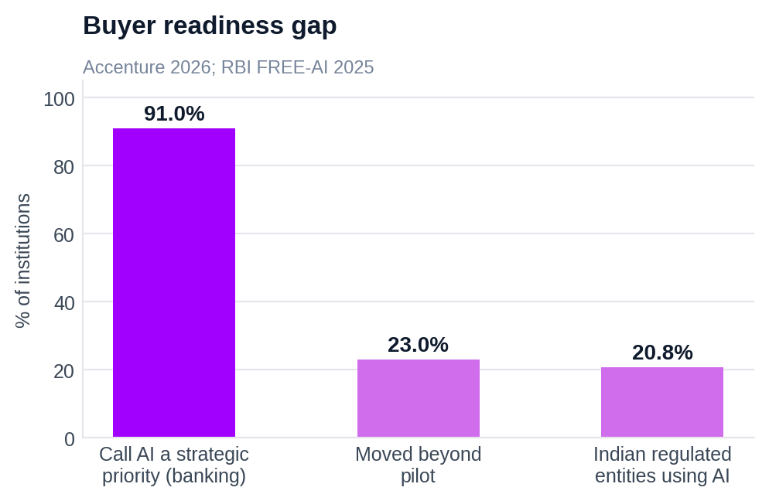
91% of banking institutions call AI a strategic priority; 23% have moved beyond pilot. In India, 20.8% of regulated entities report using AI. Sources: Accenture 2026; RBI FREE-AI 2025.
Read together, the three bars say something specific: the blocker is not appetite and not budget. It is that the second gate — model risk, audit, entitlement — is where pilots die. A product whose primary claim is traceability enters that conversation from the right side of the table.

4.2 The buying centre — who signs, who champions, who can stop it
Role in the deal | Who this is | What they are actually testing
Economic buyer | CFO or Chief Data Officer | Signs on payback and headcount leverage
Champion | Head of Analytics / Data | Owns the backlog the product removes
Technical gatekeeper | Head of Data Engineering | Tests residency, determinism and the incident path
Compliance gatekeeper | CRO / Model Risk | Tests documentation, traceability and human sign-off
Daily user | Ops managers and analysts | Adoption here decides renewal, not the pilot
The two gatekeepers cannot approve the purchase but can stop it, which is why determinism and the evidence bundle are product features rather than engineering preferences.

4.3 Segment definition and fit
Institution profile | Ops / risk / analytics staff | Data function | Governed metrics | Fit
Mid-size retail bank | 150–400 | 6–12 FTE | 10–25 | Primary — full value model applies
Regional / community bank | 50–150 | 2–5 FTE | 5–10 | Secondary — smaller absolute value
Tier-1 / G-SIB | 1,000+ | 50+ FTE | 100+ | Later — long procurement, larger prize
Digital-first / NBFC | 80–250 | 4–10 FTE | 10–20 | Strong — cleaner pipelines, faster cycle

4.4 Entitlement is enforced, not displayed
Personas are resolved server-side; a query parameter can never widen access. The Metric API applies a row-level entitlement WHERE clause taken from the KPI contract, so a restricted figure is structurally absent from the bundle the narrator sees rather than redacted after generation. Where a restricted numerator would be back-computable from a published ratio, that ratio is suppressed too — which is the check most implementations miss.
Tenancy works the same way. The tenant is selected by application name — bank_a resolves to NexaBank, bank_b to SafexBank — never by a query parameter and never by a separate database per client. Two tenants run side by side on one engine with isolated data today, and that single property is what converts a bespoke analytics build into a repeatable sales motion.
Current implementation status: the demo uses a simple dropdown for persona selection. Full role-based access control resolved from an identity provider is Phase 2 work, and is called out as such in the roadmap rather than implied to be present.

4.5 The decision workflow end to end
- Signal. A scheduled sweep or a user question identifies a KPI or business domain, pins a time window and an ingest watermark.
- Evidence. The Metric Layer reads declared fundamentals; the Trust Gate checks readiness, quality, reconciliation and freshness against SLA, and issues one of five verdicts.
- Explanation. Detect, Localize, Forecast and Causal build the finding to the depth the contract permits, and no further — the causal ceiling is declared, not discovered.
- Action. Decide proposes a contract-approved lever from a fixed ontology and names the accountable owner, with expected impact expressed as a range.
- Review. The persona sees the verified narrative and the evidence trail. A human approves any action, and the outcome is written back against the finding that proposed it.
5 / BUSINESS CASE AND IMPACT

A defensible floor, a headline range, and a stated assumption per line
The business case is deliberately built as two numbers rather than one. The defensible floor of $335–490K is the bottom-up sum of four mechanisms, each with an assumption a customer can dispute line by line. The headline range of $550–950K adds in-time decision value and reduced analyst churn, both of which are real and neither of which we can bound tightly. Quoting only the headline would be the weaker position.

$335–490K  Defensible floor, bottom-up  sum of four mechanisms | $550–950K  Headline annual value  modelled | 3–5 months  Payback period  crossover, modelled cost profile | 5–8×  Investigation throughput  per analyst

5.1 Value derivation — each line states its assumption
Mechanism | Derivation | Low | High | Basis
Analyst time | 12 investigations/wk × ~5 h reclaimed × 50 wk @ $55/h | $140K | $190K | Cost input sourced
Bad decisions | 3–4 prevented incidents/yr × ~$40K direct cost | $120K | $160K | Modelled
Reporting cycles | 2.5 people × 3 h/wk × 80% reduction × 50 wk | $25K | $40K | Modelled
Licence recovery | Idle entitlement de-provisioning + behaviour-justified upsell | $50K | $100K | Zylo 2025 anchored
Defensible floor | Sum of the four mechanisms above | $335K | $490K | Bottom-up
Headline range | Adds in-time decisions and reduced analyst churn | $550K | $950K | Modelled
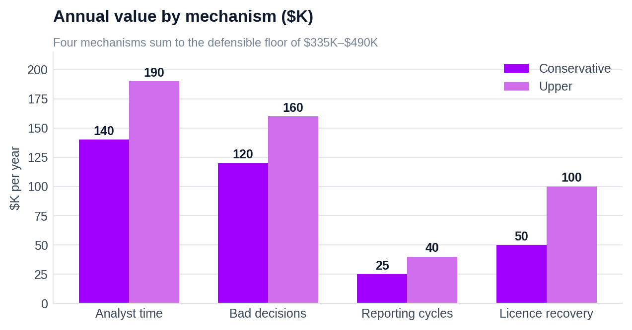
The four floor mechanisms. Analyst time is the largest single line and the only one anchored to an external cost input rather than to a modelled frequency.

5.2 Payback profile
Crossover falls between months three and five, on a bounded implementation cost plus a mid-market platform licence. Value ramps from month two — the point at which the first KPI contracts clear the Trust Gate — rather than from day one, because a contract that has not passed a gate produces nothing worth counting.
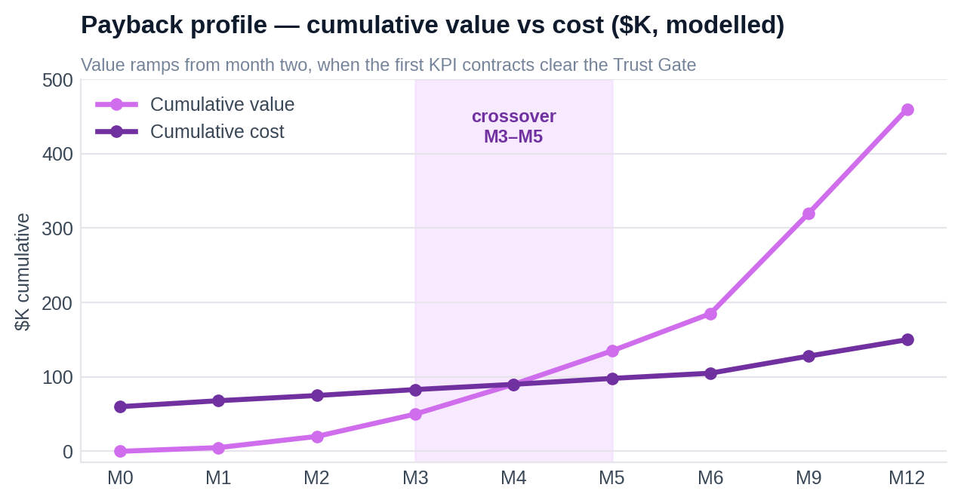
Cumulative modelled value against cumulative cost, months 0 to 12. The shaded band marks the 3–5 month crossover window.
Run cost stays bounded by design, not by discipline. Only the narrator calls a model, and Observe records tokens, latency and cost per insight, which means the marginal cost of an additional governed metric is a measured figure the customer can watch rather than a vendor estimate they have to accept.

5.3 Sensitivity — what moves the number, and by how much
Five drivers move the total materially. Presenting them explicitly is a commercial choice: a buyer who can see which assumption is load-bearing will argue about that assumption rather than dismiss the whole model.

Driver | Downside | Base | Upside | Effect on total
Governed metric count | 5 | 10 | 25 | ≈ linear on 3 of 4 lines
Upstream data quality | Clean pipelines | Mixed | Fragmented sourcing | ±$60K, bad-decision line
Reclaimable share of a day | 60% | 85–90% | 92% | ±$50K, analyst line
Roles duplicating reporting | 1 shared function | 2–3 roles | 4+ roles | ±$20K, size-independent
Loaded analyst cost (geography) | India ≈ $30K | US $110K | US $150K | Rescales the largest line
The geography line is the one that changes the shape of the argument rather than its size. At an India-loaded analyst cost the analyst-time mechanism shrinks by roughly two-thirds, and the case has to be carried by decision quality and licence recovery instead. That is a different sale, and it is worth knowing before the meeting.

5.4 Baseline and methodology
Baseline institution: a mid-size retail bank with 150–400 staff across operations, risk and analytics, a 6–12 person data function, and a metric footprint comparable to the ten governed KPIs described in section 3. Cost inputs are externally anchored — a US senior analyst at $110K fully loaded, approximately $55 per hour. Incident frequency, per-decision cost, the payback profile and the headline range are modelled from those inputs and are not measured at a client.
HOW TO READ THESE FIGURES
Every line in this section carries one of two labels. ‘Cost input sourced’ means the unit cost comes from an external reference and only the volume is ours. ‘Modelled’ means both the volume and the unit are assumptions, stated above so they can be replaced. The correct use of this business case is to run a pilot that replaces the modelled lines with measured ones — which is exactly what the Phase 1 exit criterion is designed to produce.
6 / PHASED ROADMAP

Three phases over eighteen months, each gated on evidence
Phase 1 is built and running today. Each phase exits on an evidence test a sceptic could run themselves, not on a date, and recommendations stay human-approved in every phase without exception.
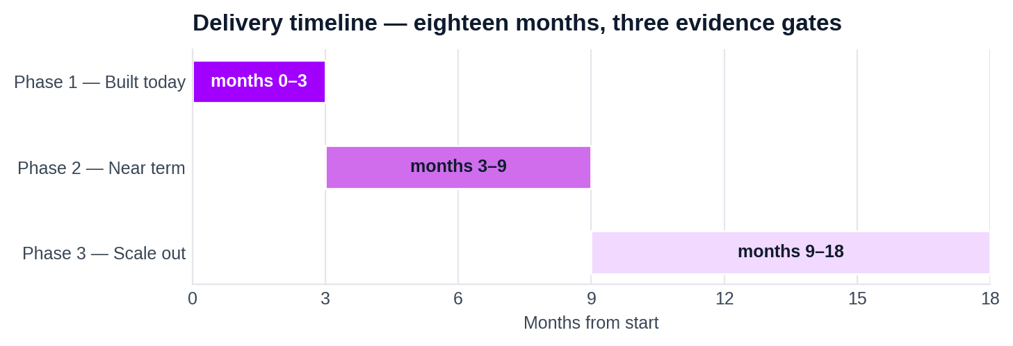

Phase | Months | Scope delivered | Exit criterion — evidence, not schedule | Gate owner
1 — Built today | 0–3 | Foundation → Trust Gate → Detect → Localize → Forecast → Causal → Decide → Narrate, live end to end on NexaBank telemetry. Three KPI contracts, ClickHouse Signal Store, Observe on every stage. | Trust Gate quarantines a seeded corrupt batch; the numeric verifier passes on every published figure; analyst review under 60 minutes | Head of Analytics
2 — Near term | 3–9 | Analyst feedback loop wired to the outcomes table; more KPI contracts across more sources; personas and entitlements widened beyond CFO, Ops Manager and Analyst. | Overrides recalibrate the next run; Risk/Audit reproduces three historic figures from the evidence bundle alone | CRO / Model Risk
3 — Scale out | 9–18 | Multi-tenant scale-out beyond NexaBank and SafexBank; Databricks, Snowflake, Fabric, Tableau, Qlik and Looker connectors — native, custom or hybrid. ClickHouse remains the analytical core. | Third tenant live with no engine change; ≥25 KPI contracts governed; documented run-rate value ≥ $500K | CFO / CDO
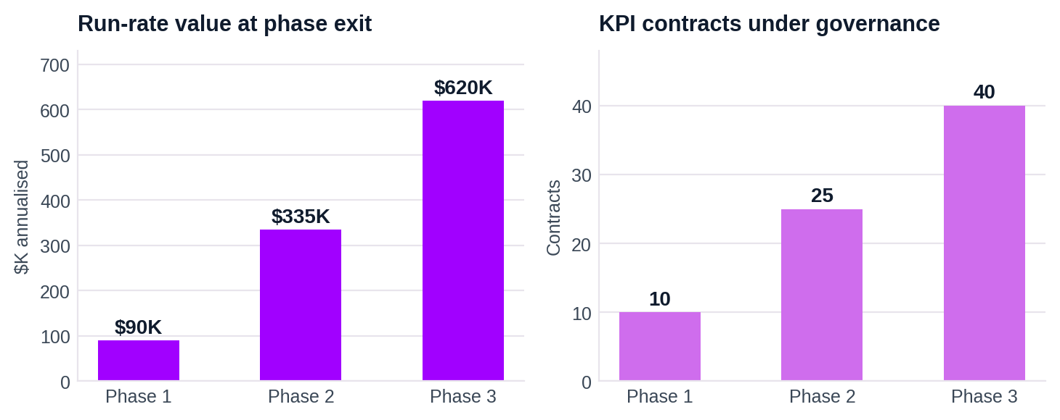
Run-rate value and governed contract count at each phase exit. The Phase 3 target of ≥$500K documented run-rate is the gate, not the forecast.

6.1 What is deliberately out of scope, in every phase
The exclusions below are not a backlog. They are boundaries, and each one exists because crossing it would break a claim made elsewhere in this proposal.

Excluded capability | Why it stays out
Automated action without human approval | Human approval sits in the delivery path: every action is approved by a named person and the outcome is logged. Removing that step would invalidate the entire regulatory posture in section 7.4.
Self-learning recommendation ranking | Overrides are captured in the outcomes table from day one, but recalibration is designed rather than deployed and lands in Phase 2. Learning must never widen the contract’s lever list.
Model-driven credit or risk decisions | Out of product scope entirely. Decide picks from a fixed lever ontology and never invents an action — which is also what keeps the system outside EU AI Act high-risk classification.

6.2 Implementation responsibilities
- Product and business own KPI definitions, materiality thresholds, decision owners, permitted levers and acceptance scenarios.
- Data and platform own source extracts, Metric Layer mappings, freshness, schema stability and tenant isolation.
- Analytics and intelligence own stage methods, Signal Store integrity, deterministic outputs and the evaluation gates at each phase exit.
- Security and governance own identity verification, role mapping, entitlement review and audit policy.
- Operations review findings, approve actions, capture outcomes and feed usefulness signals back into the outcomes table.
7 / KEY RISKS AND MITIGATIONS

Eight tracked risks; the three that would kill it are not technical
Risks are scored 1 (low) to 5 (severe), inherent and residual, with a named control and a named owner for each. The three highest-inherent risks are commercial and organisational rather than engineering problems, which is the honest reading of what happens to programmes of this shape.
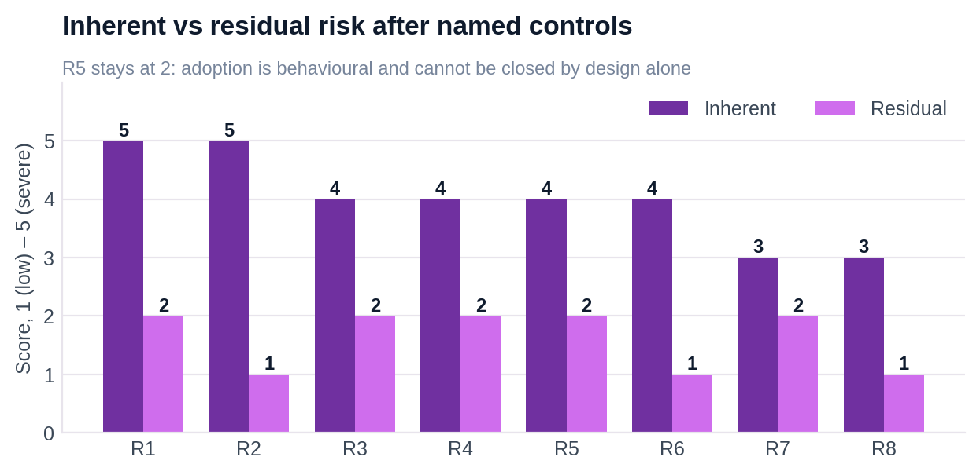
Every risk drops at least two points once its named control is in place; the two severe-inherent risks drop to 2 and 1.
# | Risk | Category | Inh | Mitigation and control | Res | Owner
R1 | Pilot delivers no measurable P&L change and is cancelled | Commercial | 5 | Scope fixed to the three KPI contracts already live on NexaBank telemetry; value measured per contract against a pre-agreed baseline | 2 | Champion
R2 | Narrator states a figure the evidence does not support | Product | 5 | Narrator sees evidence bundles, never raw events; the numeric verifier traces every figure, then regenerate, redact, template | 1 | Engineering
R3 | Taxonomy drift, or a simulated field read as real evidence | Data | 4 | Read-time canonicalisation and pre-deploy checks; simulated fields labelled in contract and narrative; quarantine rate reported | 2 | Data Eng
R4 | Model-risk or audit function blocks deployment | Regulatory | 4 | Determinism plus a per-figure evidence bundle meets SR 11-7 documentation expectations; no credit decisioning keeps it outside EU AI Act high-risk scope | 2 | CRO
R5 | Analysts treat it as a threat and withhold adoption | Organisational | 4 | Positioned as review-and-challenge; the analyst persona exposes the full evidence bundle; overrides are logged and feed Phase 2 recalibration | 2 | Head of Analytics
R6 | Tenant misattribution or a restricted figure reaching the wrong reader | Security | 4 | Tenant selected by app name, never a query parameter; personas resolved server-side; row-level entitlement WHERE clause in the Metric API | 1 | Security
R7 | Duplicate events from at-least-once delivery inflate a KPI | Data | 3 | Replay-safe aggregation, exact-distinct on every count; Bronze append-only with event_ts and ingest_ts preserved; Trust Gate reconciles | 2 | Data Eng
R8 | LLM cost and latency creep as insight volume grows | Cost | 3 | Narrator-only small-model design; Observe records tokens, latency and cost per insight; narrator optional, degrades to a template | 1 | Engineering
Residual scores assume the stated controls are implemented and tested at the phase gate they belong to. R5 remains at 2 rather than 1 because adoption is behavioural and cannot be closed by design alone; it is re-scored at the Phase 2 gate on observed analyst usage.

7.1 The three that would actually kill it, and the external evidence behind each
Risk | External evidence | Control
R1 · Pilot cancelled without measurable value | Gartner forecasts over 40% of agentic AI projects cancelled by end-2027 on escalating cost, unclear value and weak risk controls. S&P Global found 42% of firms abandoned most AI initiatives in 2025, scrapping 46% of proofs-of-concept. | Value is measured per governed metric against a pre-agreed baseline, and each phase gate is an evidence test a sceptic can run.
R2 · A fluent answer the data does not support | The best models score roughly 21% on enterprise-schema text-to-SQL against roughly 91% on academic benchmarks. A wrong answer arrives in the same confident prose as a right one. | The narrator receives typed evidence bundles only; the numeric verifier traces every figure to the Signal Store, then bounded regeneration, redaction, template.
R5 · Adoption stalls inside the analyst function | Klarna publicly reversed part of its support automation in 2025 and rehired human agents after over-automating. The pattern is over-reach, then retrenchment. | Nothing acts on its own. Human approval sits in the delivery path, every action is approved by a named owner, and the outcome is logged.

7.2 Product-level risks carried from the build
Risk | Potential consequence | Mitigation / boundary
Synthetic dimensions mistaken for measured data | Confident but meaningless root cause | Fabricated fields are marked in contract and narrative, invariance is measured, and they are refused from localisation outside seeded datasets
Stale or incomplete batch source | False decline or phantom zero | Watermarks, freshness gates against SLA, source-presence checks and explicit abstention rather than a zero
Entitlement misconfiguration | Restricted data reaches the wrong reader | Server-side identity and persona resolution; contract visibility applied before narration; back-computable ratios suppressed
Action interpreted as automation | Unapproved policy or operational change | Closed lever list, named owner and an explicit human approval requirement in the delivery path
Phase 1 scope expansion | Complexity and unclear acceptance criteria | Automated actions, self-learning recommendation ranking and broader security hardening stay in the roadmap, not the pilot

7.3 Regulatory posture
Two regimes matter for a product of this shape in this segment. Determinism plus a per-figure evidence bundle addresses SR 11-7 model-risk documentation expectations directly: the model inventory entry can point at a reproducible numeric path rather than at a black box with a validation report attached. And because the product makes no credit or risk decisions — Decide proposes from a fixed lever ontology and a human approves — it stays outside EU AI Act high-risk classification, which is a deliberate scoping choice rather than a fortunate accident.
The compliance gatekeeper’s actual test is narrower than either regime suggests: can Risk or Audit reproduce a figure that was published six months ago, from the stored evidence alone, without asking an engineer? That is written into the Phase 2 exit criterion as a concrete test on three historic figures.
8 / MEASUREMENT AND SUCCESS CRITERIA

Success is a set of operational proofs, not a volume of text
The product should be evaluated on whether it produces a better decision workflow. Each dimension below is stated as something a customer can test on their own data during the pilot.

Dimension | Success measure
Truth | Every narrated figure traces to a Signal Store row or a contract field; verifier coverage is 100%
Reliability | Defect scenarios are quarantined; ambiguous scenarios abstain with a named confirming check
Detection | Planted movement is found while normal windows remain quiet — both halves matter
Localization | The planted segment is ranked correctly using additive, measured dimensions only
Forecasting | Every eligible KPI has a stored interval, method and caveat, or an honest sparse-history response
Consistency | The same frozen rows produce byte-identical numeric Signal Store outputs
Governance | No restricted KPI, and no back-computable restricted figure, reaches an unauthorised persona
Adoption | Users answer supported questions without a data-team ticket and can identify source, window and owner
Action | Recommendations are contract-approved, owner-assigned and human-approved; outcomes are recorded
Economics | Observe reports tokens, latency and cost per insight; cost per governed metric is a measured figure

8.1 Value-realization scorecard for the pilot
- Baseline first. Measure the current investigation cycle before anything is switched on: elapsed time, analyst hours, handoffs and rework per movement. Without this the value model stays modelled forever.
- Decision quality. False positives suppressed, ambiguous cases correctly withheld, and evidence disputes resolved without escalation.
- Adoption. Supported questions answered without a data-team ticket, repeat users, and persona usage by role.
- Action. Recommendations accepted, owner response time, and the share of findings that reach a review decision.
- Platform economics. Tenants onboarded, governed KPIs per tenant, storage cost and intelligence runtime cost per insight.
9 / COMMERCIAL PACKAGING AND GO-TO-MARKET

Lead with one expensive decision loop
The entry point is not a dashboard replacement. It is a single decision loop in lending and onboarding, where a delayed or untrusted answer carries a visible operational cost. Start with KYC completion, loan approval rate and loan approval volume — the three contracts already live — and prove that one evidence chain moves from signal to source validation to explanation to owner to action. Expand into deposits, acquisition and product usage once the operating habit exists.

Motion | Offer | Customer proof
Land | One tenant, three connected KPIs and one operating persona set | Time-to-answer, trust verdicts and action ownership measured against the current process
Prove | A controlled pilot with normal, defect, sparse-history and permissions scenarios | No unsupported figures, no entitlement leaks, and correct treatment of ambiguous data
Expand | Additional finance, acquisition and product metrics through contract workshops | More governed coverage without proportional engineering effort
Scale | Multi-tenant platform and the source connector programme | A second institution onboarded through contracts and mappings, not stage rewrites

9.1 Packaging
- Foundation package: tenant onboarding, source mapping, the KPI contract workshop, the access model and a readiness dashboard.
- Decision intelligence package: the scheduled eight-stage chain across an agreed KPI set, with Observe telemetry exposed to the customer.
- Persona and governance package: role-specific views, entitlement controls, evidence cards and the audit trail.
- Expansion package: additional tenants, Tier 0 to Tier 1 contract promotion, source connectors and the outcome feedback loop.

9.2 Why this is differentiated
- Versus BI: it states whether a movement is credible and what to do next, not only what happened.
- Versus alerting: it controls false discoveries and collapses related KPI movements into one business story instead of three alerts.
- Versus conversational analytics: it refuses unsupported answers, preserves the claim set, and applies access before narration rather than after.
- Versus bespoke analytics consulting: contracts and the Metric Layer create a repeatable onboarding motion across tenants and domains.
10 / RECOMMENDATION

Approve a governed pilot on the lending and onboarding loop
BusinessIntelligence.ai has a clear product boundary and a credible wedge: make existing analytics trustworthy, explainable and actionable for the people who already carry the decision. The architecture is already shaped for a repeatable multi-tenant platform, with two tenants running side by side on one engine today. The business case is strongest when the first pilot measures the baseline rather than asking the narrative layer to prove value by itself.
The recommended decision is to proceed with a controlled pilot centred on lending and onboarding, where KYC completion, loan approval rate and loan approval volume form one connected business story. Add finance and acquisition metrics after the trust and entitlement workflow is proven. Use the pilot to replace the modelled lines in section 5 with measured ones: investigation time, false-positive suppression, answer adoption, recommendation acceptance and realised operational impact.

DECISION REQUESTED
Authorise a KPI-contract and source-readiness pilot for one tenant, with Operations, Finance, Analytics and Risk represented in acceptance. Phase expansion is gated by evidence quality, not by narrative fluency — the Phase 1 exit criterion is that the Trust Gate quarantines a seeded corrupt batch, the numeric verifier passes on every published figure, and analyst review completes in under sixty minutes.

APPENDIX A

Terms used in this proposal

Term | Meaning in this product
KPI contract | The declared business meaning, source fundamentals, grain, quality rules, dimensions, ownership, levers and visibility for a metric. One YAML file per metric.
Trust Gate | The stage that decides whether a figure may be used at all, issuing one of five verdicts: PASS, QUARANTINE, WIDE BAND, ABSTAIN or WITHHOLD.
Tier 0 | Automatically discovered metric coverage with conservative statistical and entitlement behaviour.
Tier 1 | Hand-authored business KPI with ratios, invariants, causal configuration, actions and access rules.
Signal Store | The durable evidence store on ClickHouse for investigations, trust findings, anomalies, forecasts, causes, recommendations and model runs.
Evidence bundle | The typed set of verified figures and provenance the narrator receives. It never contains raw events, and a withheld figure is structurally absent from it.
Persona | A role-shaped view over one verified claim set. It changes emphasis, depth and entitlement — never the underlying number.
Investigation | One tenant, one KPI and one pinned time window processed through the eight stages.
Modelled figure | A derived or simulated value that carries a qualifier every time it is presented, in every persona.
Observe | Cross-stage telemetry recording latency, tokens, cost and verifier status per stage, which makes run cost a measured quantity.
Lever ontology | The fixed, contract-declared list of actions Decide may propose. Nothing outside the list can be recommended.

APPENDIX B

External evidence register
Every external figure used in this proposal, with its source and the claim it supports. Nothing in this table is our measurement.

Figure | Source | Used to support
$12.9M average annual cost of poor data quality per organisation | Gartner, 2020 | Scale of the data-quality problem (section 1)
67 data incidents per team per month; ~15 hours to resolve each | Monte Carlo / Wakefield, 2023 | Volume of the reconciliation burden (section 1)
90–95% false-positive rate on AML transaction-monitoring alerts | OCC / Datos Insights, 2023 | Why alerting surfaces get muted (section 1.4)
67% of organisations do not completely trust their data for decisions | Precisely / Drexel, 2025 | Trust as the binding constraint (section 1)
52.7% of purchased SaaS licences go unused | Zylo, 2025 | Idle entitlement and licence recovery lines (sections 1.3, 5.1)
91% of banking institutions call AI a strategic priority; 23% beyond pilot | Accenture, 2026 | The buyer readiness gap (section 4.1)
20.8% of Indian regulated entities report using AI | RBI FREE-AI, 2025 | The buyer readiness gap (section 4.1)
Over 40% of agentic AI projects forecast cancelled by end-2027 | Gartner | R1, pilot cancellation risk (section 7.1)
42% of firms abandoned most AI initiatives in 2025; 46% of PoCs scrapped | S&P Global, 2025 | R1, pilot cancellation risk (section 7.1)
~21% enterprise-schema text-to-SQL accuracy vs ~91% academic | Published benchmark comparison | R2, unsupported fluent answers (sections 1.4, 7.1)
Partial reversal of support automation and rehiring of human agents | Klarna, 2025 | R5, adoption and over-automation risk (section 7.1)
US senior analyst $110K fully loaded, ~$55/hour | Cost input, externally anchored | Every analyst-time line (sections 1.2, 1.3, 5.1)

Methodology note: Gartner 2020 is a self-estimate by enterprise reference customers, and Monte Carlo 2023 is a vendor-commissioned Wakefield survey (n=200). Both are cited as directional scale rather than as precise measurements. Every figure in this document labelled ‘modelled’ derives from stated volume and unit-cost assumptions and is not measured at a client.
N / APPENDIX: EXTERNAL EVIDENCE REGISTER

Ref ID | Title / Citation Source | Document Mapping / Usage Context | Direct Link / Reference URL
E1 | Federal Reserve Board — SR 26-2: Revised Guidance on Model Risk Management (17 Apr 2026) | Supersedes SR 11-7; establishes risk-based model governance standards [1, 22, 23, 27]. | URL
E2 | OCC Bulletin 2026-13 — Model Risk Management: Revised Guidance (17 Apr 2026) | Confirms interagency update and rescission of prior MRM guidance [1, 22, 23]. | URL
E3 | FDIC Quarterly Banking Profile (Q1 2026) | Industry performance context across 4,278 insured institutions [1, 2]. | URL
E4 | Reserve Bank of India — Scheduled Bank Statement (2025) | Market statistics across 135 scheduled commercial banks in India [1, 18]. | URL
E5 | Reserve Bank of India — FREE-AI Committee Report (Aug 2025) | Sets out the 7 Sutras and 26 recommendations for AI in finance [1, 18]. | URL
E6 | Bank for International Settlements — Regulation and Supervision of Financial Sector AI (20 May 2026) | Guidance on managing model, third-party, and cyber risk in financial AI [1, 2]. | URL
E7 | Bank for International Settlements — Artificial Intelligence in the Financial System (5 May 2026) | Risk management framework for safe enterprise AI adoption [1, 2]. | URL
E8 | Accenture — Banking Top Trends 2026 Report | Analyzes banking AI scaling, governance, and asset trends [1, 2]. | URL
E9 | Microsoft Learn — Ask Copilot Questions About Your Data in Power BI (May 2026) | Benchmarks semantic-model Q&A capabilities in enterprise BI [1, 2]. | URL
E10 | Microsoft Learn — Copilot in Power BI Tutorial (2026) | Addresses Copilot nondeterminism and output verification [1, 2]. | URL
E11 | Databricks — AI/BI and Genie Release Notes (2026) | Evaluates conversational analytics agents and semantic views [1, 30]. | URL
E12 | Snowflake Documentation — Cortex Agents & Semantic Views (2026) | Details managed agent orchestration and governed execution [1, 2]. | URL
E13 | Snowflake Release Notes — Cortex Analyst Transition to Cortex Agents (28 Aug 2026) | Highlights shift toward multi-step agentic data workflows [1, 2]. | URL
E14 | Palantir Foundry Documentation — AIP Overview (2026) | Industry benchmarks for operational AI and audit governance [1, 2]. | URL
E15 | Palantir Foundry Documentation — Why Create an Ontology? (2026) | Defines decision-centric ontology connecting data, logic, and action [1, 2]. | URL
E16 | EUR-Lex — Regulation (EU) 2024/1689 (EU AI Act Official Text) | Defines Article 6 and Annex III high-risk AI classification rules [1, 25, 26]. | URL
E17 | Accenture — Banking Top Trends 2026 (Identity & Access Control) | Recommends specific governance rules for enterprise AI agents [1, 2]. | URL
E18 | Accenture — Banking Top Trends 2026 (AI Scaling & Trust) | Examines adoption barriers and trust requirements for AI scaling [1, 2]. | URL
Ref 1 | Gartner Research — Cost of Poor Data Quality (2020) | Anchors average annual cost of poor data quality at $12.9M [1, 7, 10]. | URL
Ref 2 | Monte Carlo / Wakefield Research — State of Data Quality Survey (2023) | Documents 67 monthly data incidents taking ~15 hours to resolve [1, 11, 12]. | URL
Ref 3 | OCC / Datos Insights / PwC — AML False Positive Benchmarks (2023) | Identifies 90%–95% false-positive rate on transaction alerts [1, 13, 15]. | URL
Ref 4 | Precisely / Drexel University — Data Integrity Trends & Insights (2025) | Shows 67% of organizations lack complete trust in internal data [1, 16, 17]. | URL
Ref 5 | Zylo — SaaS Management Index Report (2025) | Establishes benchmark showing 52.7% of SaaS licenses are unused [1, 8, 19]. | URL

Sources
- Banking AI Pitch Transformation
- detailed doxs
- Document Topic Research Plan
- Document Reference and Research Mapping
- One click All Assignment Submission URL for ANIMATIONs
- KIITEE-2022(Phase - IV) e-AdmitCard
- Fwd: Dell Service Tag: 3VG94Y3 [Case Number: 221982721/Service Request: 1251933905] [ thread::h2KVuNjCKi24GG4Nv9rRvT0:: ]
- Missing Link: Finalize your track project for INDIA RUNS!
- ICC_Problem_Statement.pdf
- Invite for Indian Case Challenge 2025
- Action Required: Your project status is still marked as [Empty]
- KIITEE-2022(Phase - III) e-AdmitCard
- One click All Assignment Submission URL for ANIMATIONs
- Problem Statement for ICC 2024 (Round-1)
- KIIT ADMIT CARD
- Url of live session 15 jan, SWAYAM handbook , Maya guide & additional resources.
- Your Dell Order Has Been Received | Tag 3VG94Y3 | Case 226581204
- Track 2 Is Live: Your Step-by-Step Guide to Pitching a Winning AI Strategy
- Track 2 Is Live: Your Step-by-Step Guide to Pitching a Winning AI Strategy
- Here's everything you need to know about INDIA RUNS.
- Action Needed: Update Your Saved HDFC Bank NetBanking URL
- Copy of Portia · SlidesCarnival
- Reminder for Indian Case Challenge 2024 Submission Deadline
- Request to join your team for Indian Case Challenge 2024 (ICC) being organized by Indian Institute of Technology (IIT), Kharagpur
- Hurray! Your team is complete for Indian Case Challenge 2024 (ICC) being organized by Indian Institute of Technology (IIT), Kharagpur
- Registration Initiated | Confirmation pending from member | Indian Case Challenge 2024 (ICC)

